The My Gift Program, Great for Giving Anytime!

Each year, the My Gift Program offers unique items for members to show their support for our philanthropy. All donations benefit the Convalescent Endowment Fund (CEF), and your Temple will receive credit for your contribution.

For the Children pins make wonderful gifts. There are a total of ten pins, each with a unique design depicting children leading productive and healthy lives. The 2015 pin showcases kids with ABC Blocks. Now is the perfect time to begin collecting or to complete your set.

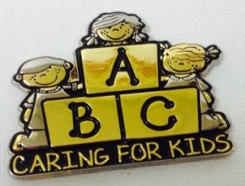

Past Supreme Queen Marsha Sowers selected the exciting new “Season of Children” collectible ornament, “Nuit”. This beautiful pewter ornament is the 17th in the series of Egyptian-themed ornaments, each telling a special story. This is a wonderful time to start or add to your collection of these special ornaments.

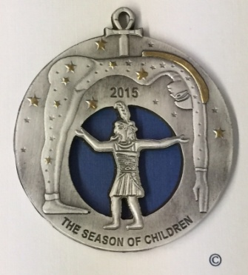
Give a Gift…...Get a Gift

For more information, please contact:
Doriann Stein, Chairman
8509 Fairway Bend Drive, Ft. Myers, FL 33967-5515

Email: wewawo@msn.com Phone: (239) 481-3356
The My Gift Program is proud to introduce the NEW “Circle of Love” Pledge Item. The theme represents the love and unity the Daughters of the Nile express for the special patients of Shriners Hospitals for Children®. This Pledge item is available for a donation of $250, or a 5-year commitment of $50 per year. After your first payment, you will receive the corresponding pin which demonstrates your commitment to the children.

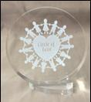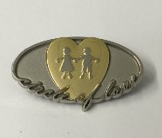
Circle of Love Lucite
Circle of Love Pin

The My Gift Program provides you with beautiful gifts in remembrance of special events and to recognize the special people in your life. Your donation is tax-deductible. Remember, we can all make a difference, one child at a time!

All these items, and many more, are available through the online Gift Store at www.donfdn.org or by mailing an order form along with your check or money order.
Nuit

